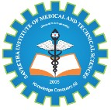

SIMATS ENGINEERING

Saveetha Institute of Medical and Technical Sciences
Chennai- 602105

Student Name: Mugesh R Reg. No.:192524454
Course Code: CSA1707 Slot: B
Course Name: ARTIFICIAL INTELLIGENCE

Course Faculty: Veeramani R
Project Title: DocInsight AI: An Intelligent Document Analysis and Question Answering System
Module Photographs:
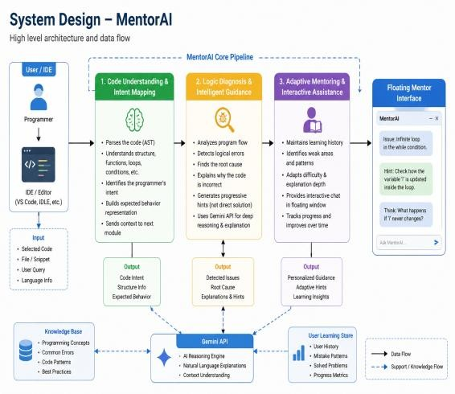
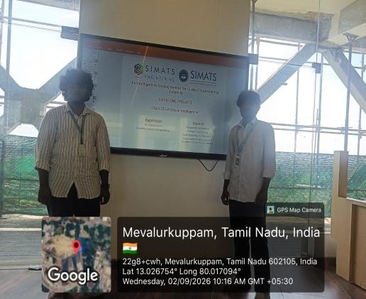
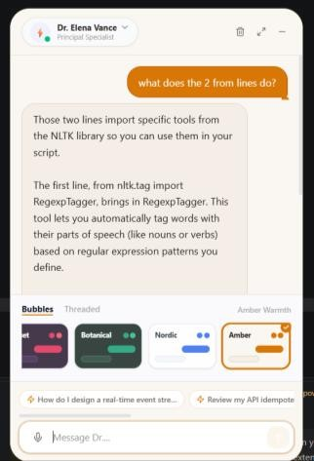

Project Description:

DocInsight AI uses semantic search and knowledge retrieval to understand the meaning of user queries and find the most relevant information from uploaded documents. The module converts document content into meaningful representations, retrieves contextually related information, and provides accurate answers based on the document content.The system can be useful for students, researchers, educators, and professionals for quickly accessing information from large documents. Overall, DocInsight AI aims to provide an efficient, intelligent, and user-friendly solution for document analysis and knowledge retrieval.

Student Signature Guide Signature

